**Ganadipathy Tulsi's Jain Engineering College**

Kaniyambadi - Vellore - 632102

**NAAN MUDHALVAN - PROJECT**

**CREATE A REEL DESIGN USING CANVA**

### 

### *Submitted By,*

Team Leader - Priyadharshini.S

Team Member 1 - Dhivyasribai.B

Team Member 2 - Ajith Kumar.M

Team Member 3 - Lokesh Kumar.R

# Project Mentor Project Evaluator Project Spoc

## Mrs.Priya Mrs.Priya Mr.Durai Kumar

**INDEX**

**1. INTRODUCTION**

1.1 PROJECT FLOW

**2. PROBLEM UNDERSTANDING**

2.1 NAVIGATION

**3. SEARCH “CANVA”**

3.1 CREATE A DESIGN

**4. SIGN IN**

**5. CREATE A DESIGN**

**6. INSTAGRAM REEL**

6.1 SEARCH REEL AND SELECT IT

**7.SELECT TEMPLATES**

**8. ADD PAGES**

8.1 ADD A NEWPAGE

1. **EDIT TEXT CONTENT**

**10.ADD LOGO**

**11.BACKGROUND COLOUR**

11.1 SELECT THE BACKGROUND

**12.INCREASE/DECREASE THE PAGE LENGTH**

**13.TRANSITION**

**14.TEXT EFFECTS**

**15.SHARE AND DOWNLOAD**

1. **RESULT**

16.1 BUSINESS URL

16.2 REEL URL

**1. INTRODUCTION**

**1.1 PROJECT FLOW**

**Planning:** Create a reel design for instagram to showcase best book by name of “Series Showcase” using canva.

**Canva Registration:** Sign up for a Canva account if you don't have one already.

**Choose a Template:** Browse through Canva's instagram reel templates and select one template which is good and elegant.

**Customization:** Use Canva's drag-and-drop editor to customize the chosen template. Add your own text, images, logos, and branding elements. Adjust fonts, colors, and layout as needed.

**Functionality:** Add interactive elements such as text box,image and colours to make your reel awesome and intresting.

**2. PROBLEM UNDERSTANDING**

This project aims to design and develop a visually instagram reel for showcase the unique best books by utilizing Canva, a user-friendly graphic design tool. Participants will leverage Canva's features to create an interactive and responsive reel that meets modern design standards. The project involves conceptualizing the instagram reel layout, selecting appropriate colors and fonts, designing custom graphics and icons, and arranging content elements cohesively.

**2.1 NAVIGATION**

Navigate to : **<https://www.canva.com/>**

**3.SEARCH “CANVA”**

Search Canva in the search bar

**3.1 CREATE A DESIGN**

Here the home page of Canva

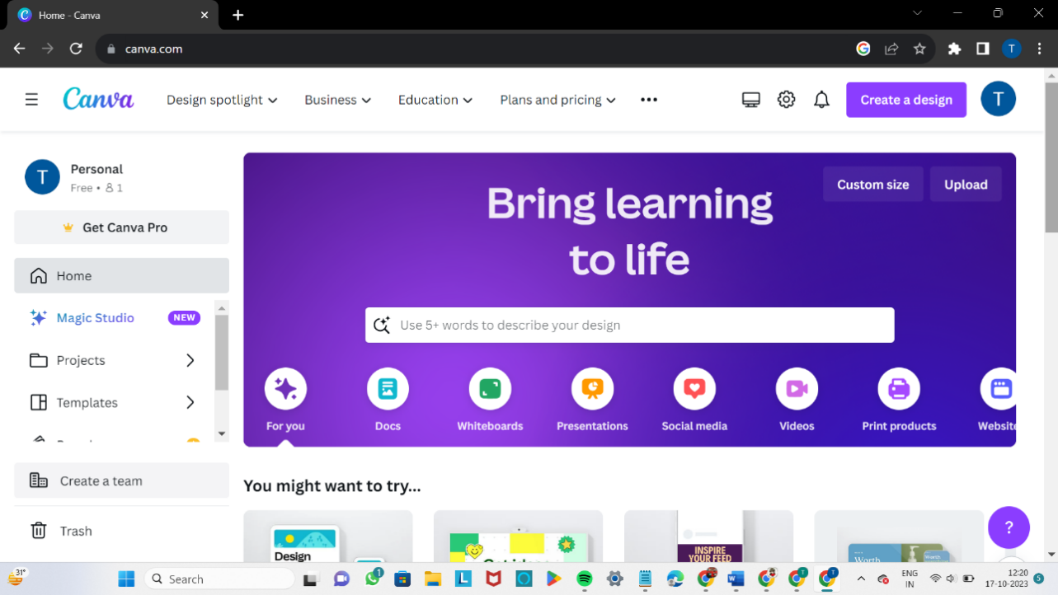

**4.SIGN IN**

After searching the canva application sign in to create a design

**5.CREATE A DESIGN**

Click “Create a Design”

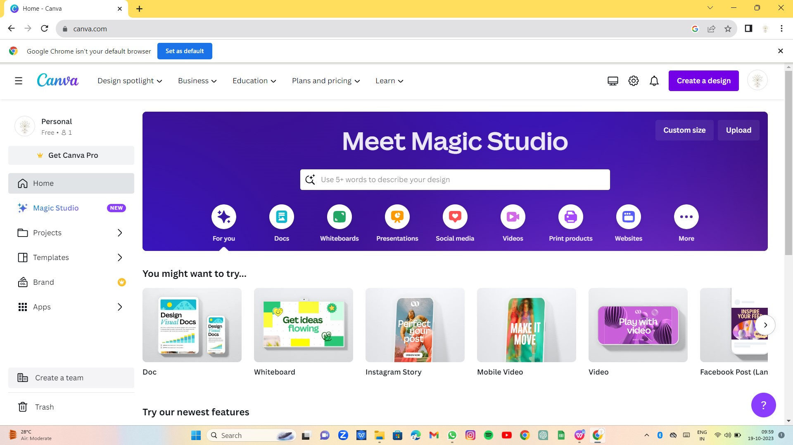

**6.INSTAGRAM REEL**

Create a Instagram Reel by using canva application.

**6.1 SEARCH REEL AND SELECT IT**

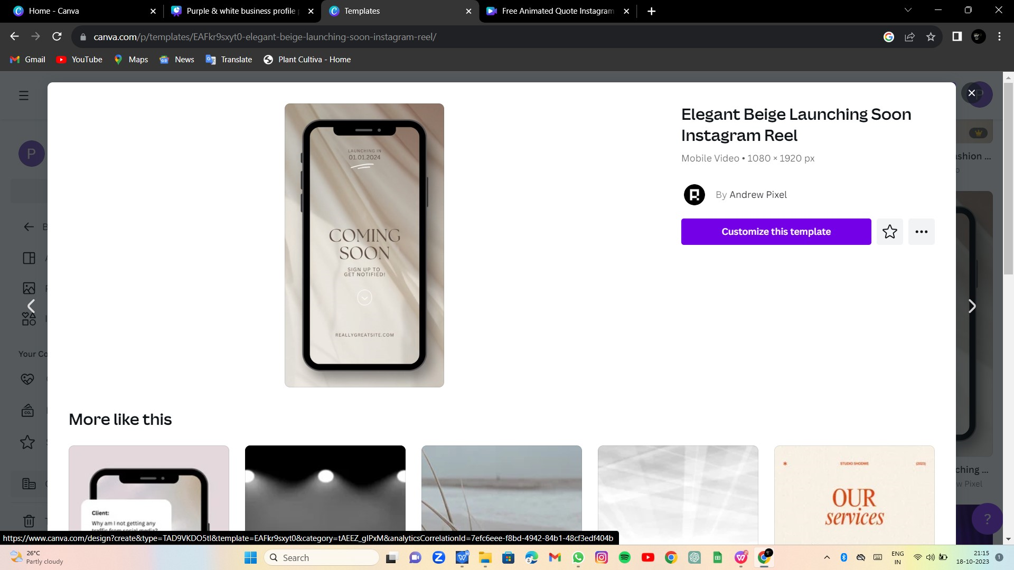

**7.SELECT TEMPLATES**

Search the Instagram reel template and select it.

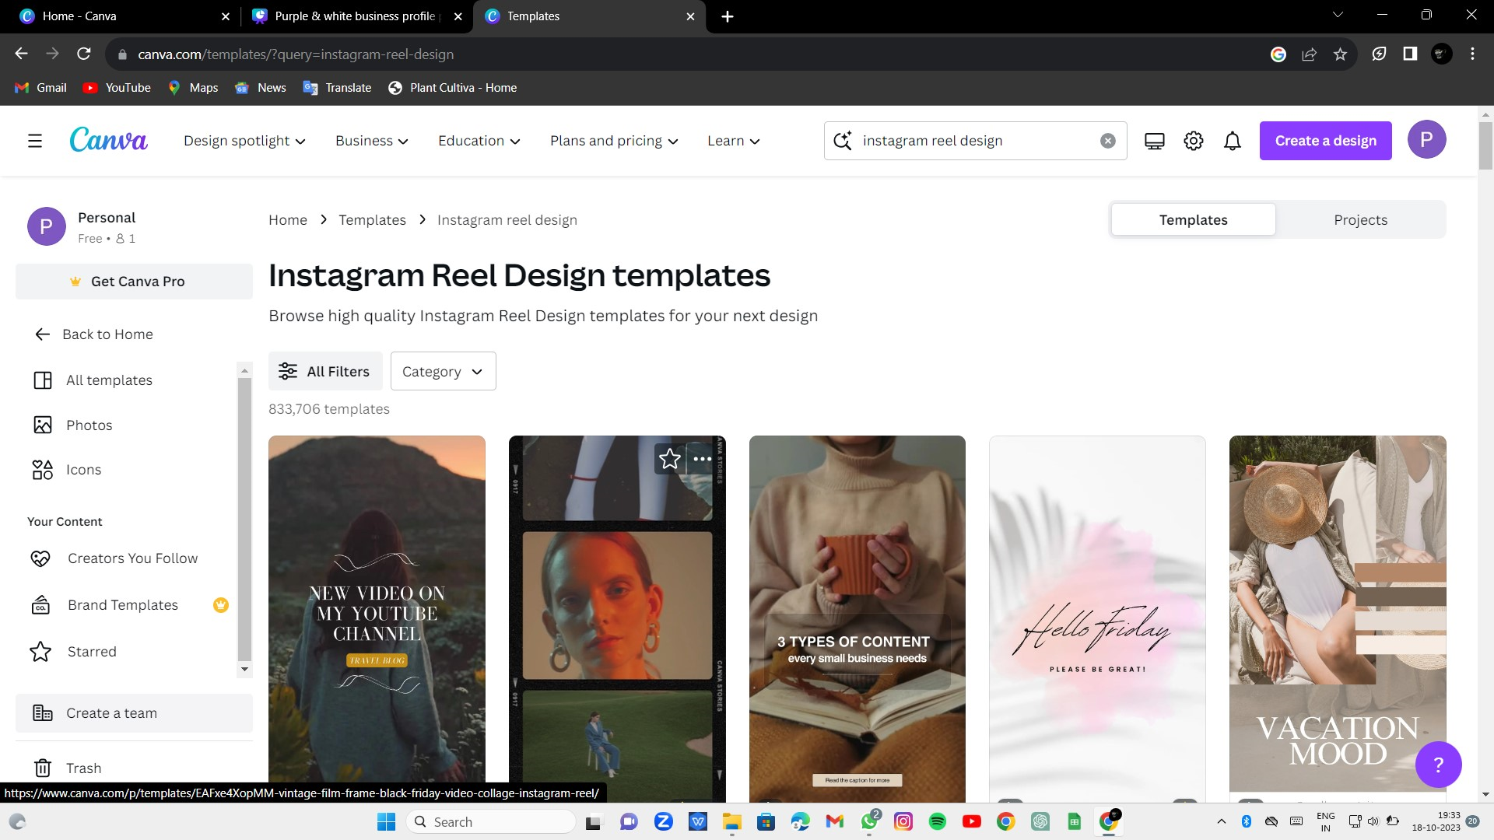

1. **ADD PAGES**

Add a new pages to include additional pages and create a proper reel design

**8.1 ADD A NEW PAGE**

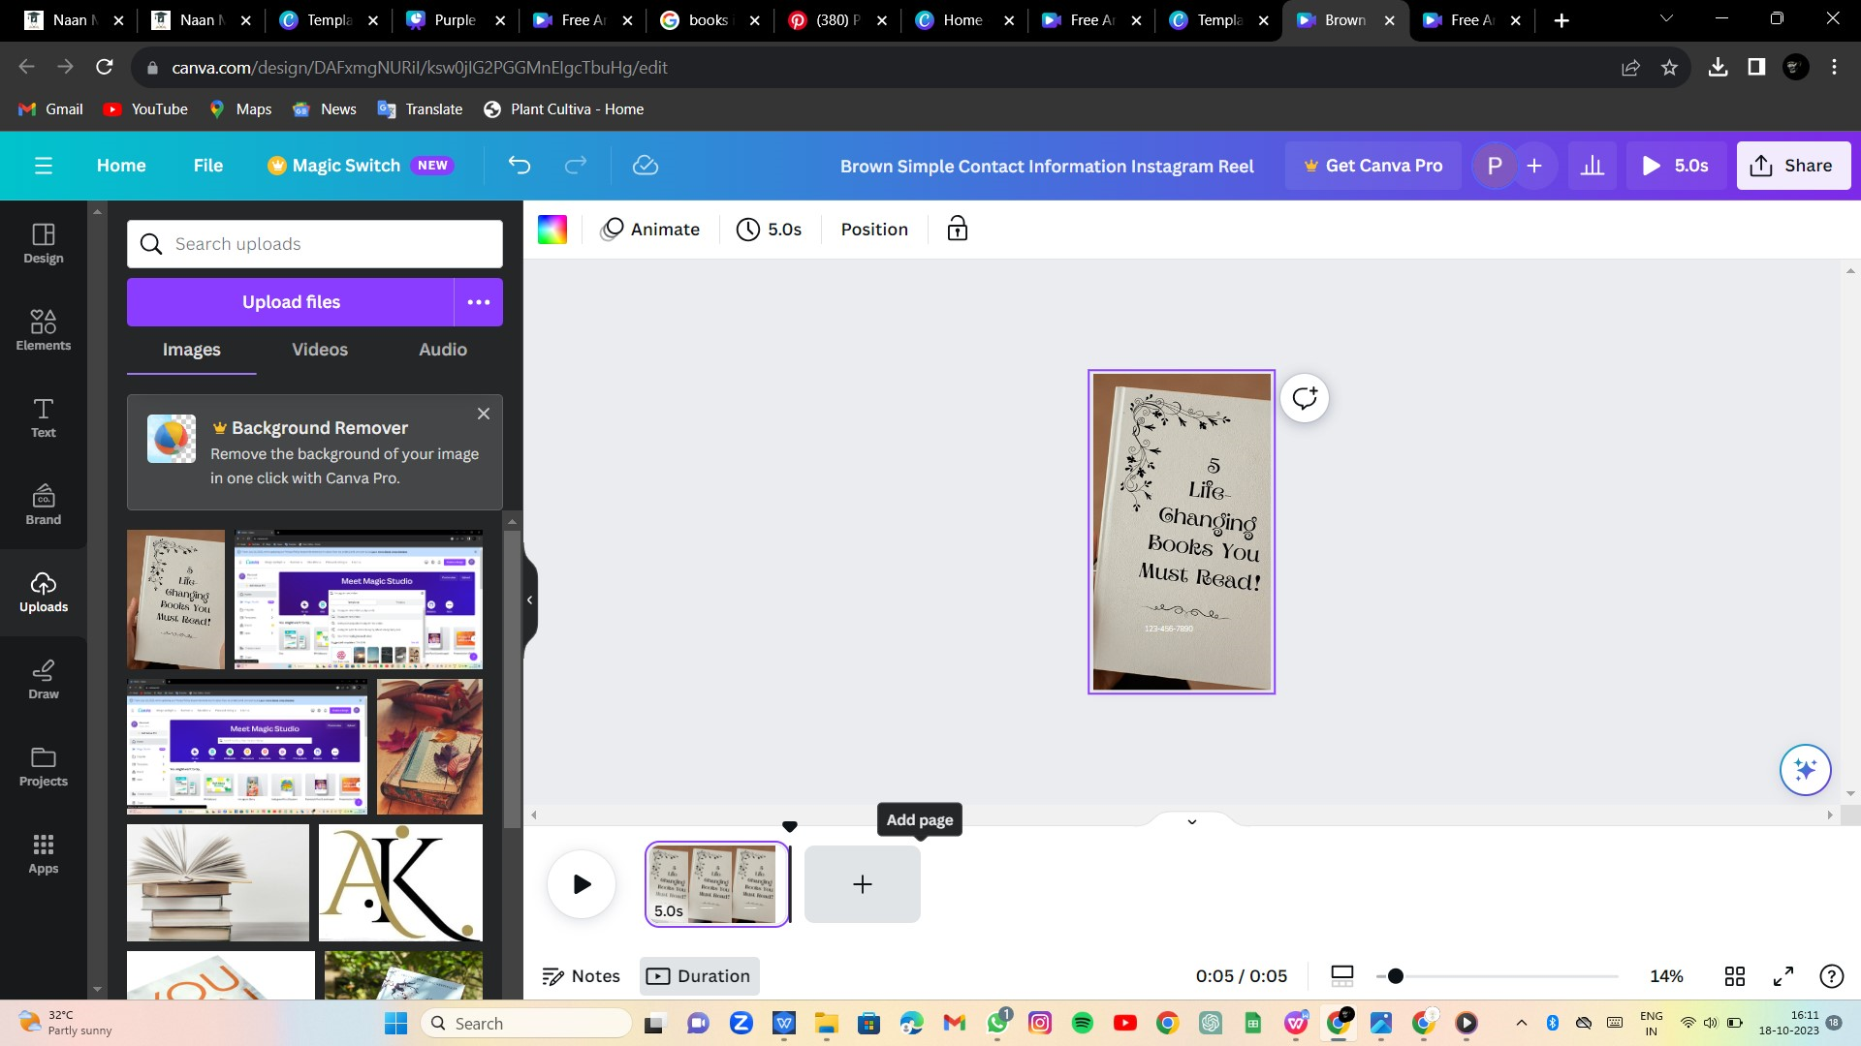

**9.EDIT TEXT CONTENT**

Select the Text And You can Edit it to your Style

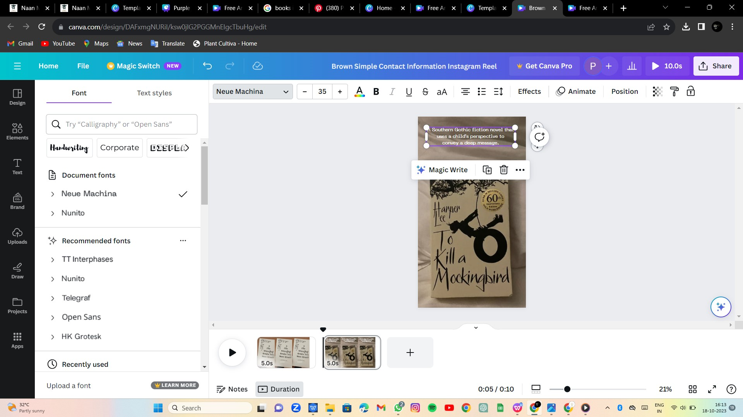

**10.ADD LOGO**

Click Uploads to add your own Images ,Logo,Video or Audio

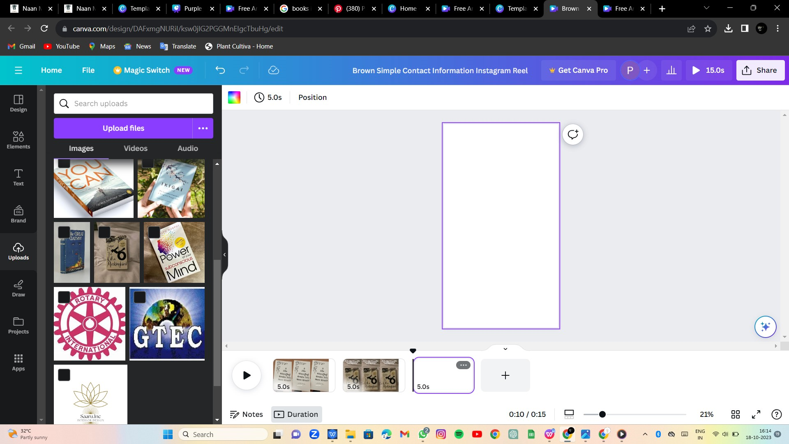

**11.BACKGROUND COLOUR**

**11.1 SELECT THE BACKGROUND**

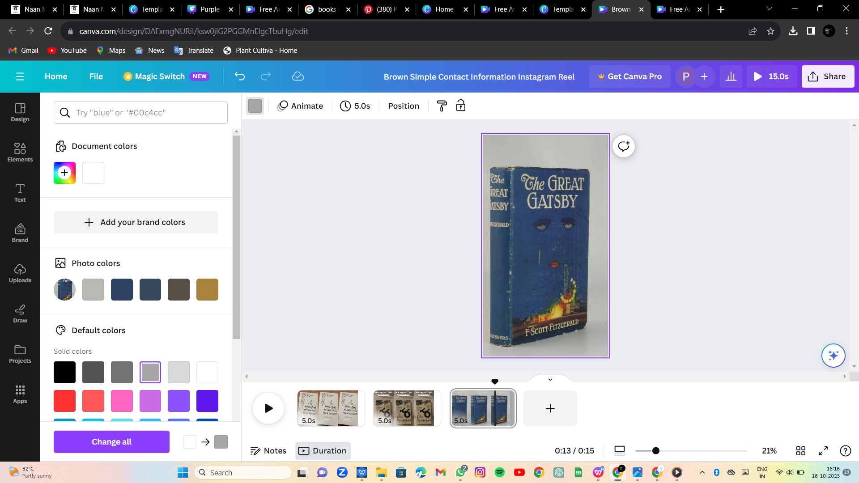

**12.INCREASE / DECREASE PAGE LENGTH**

You can increase or decrease the length of the video by selecting the edge and dragging it.

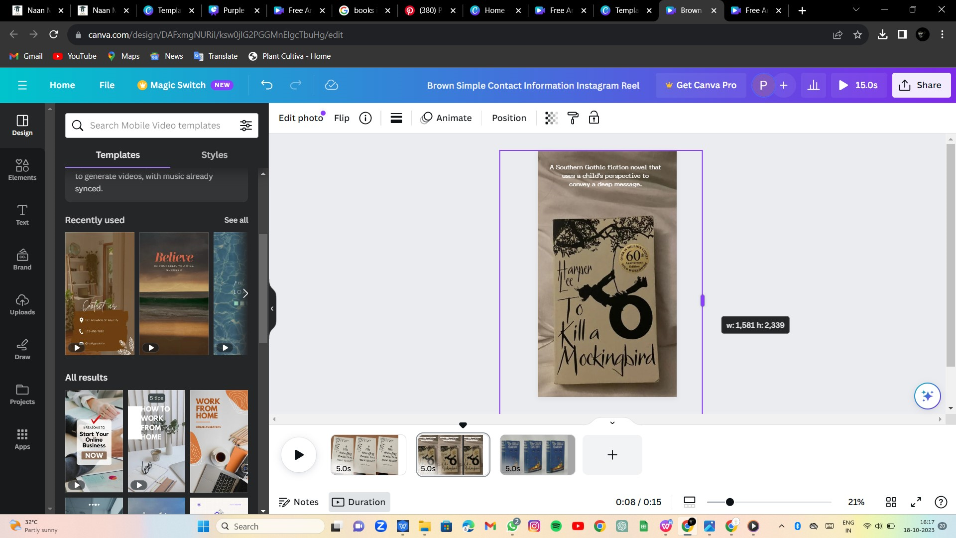

**13.TRANSITION**

Select this button add transition in between videos

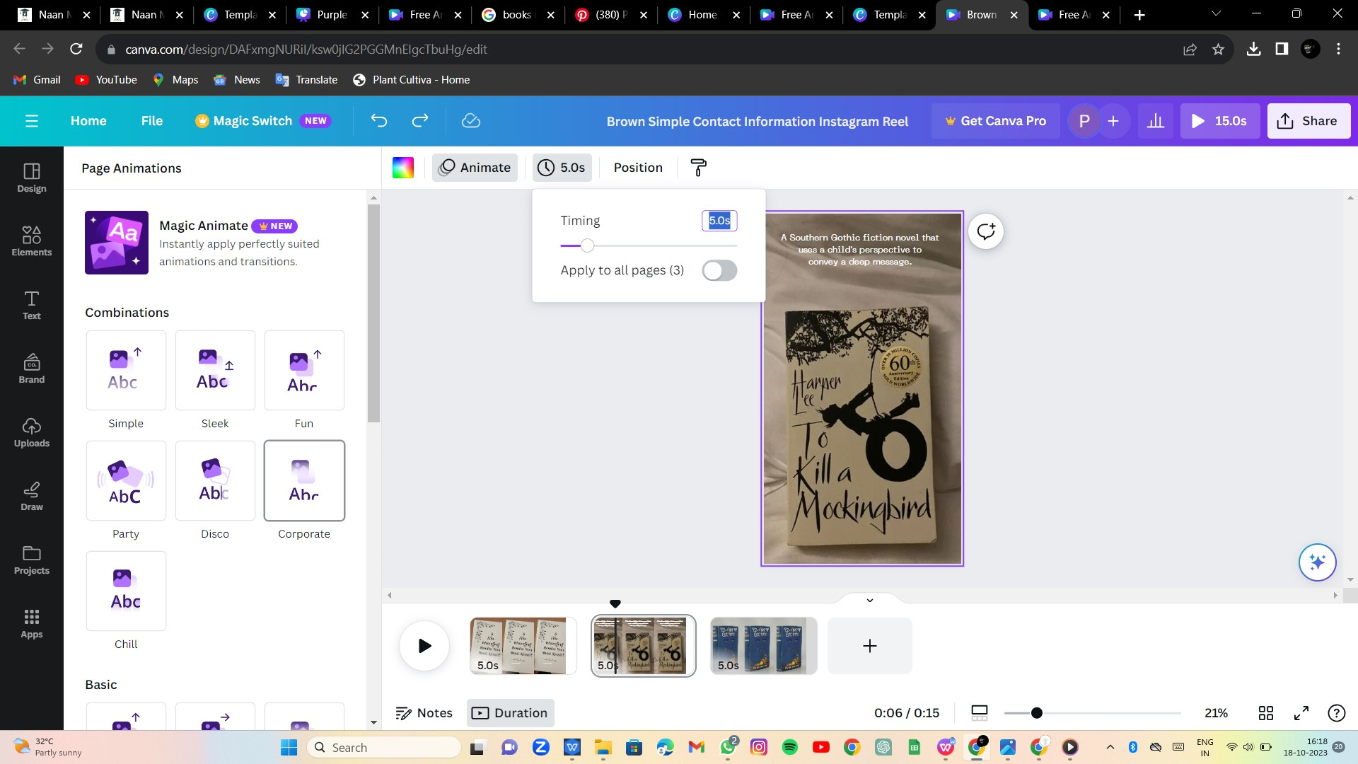

**14.TEXT EFFECTS**

Click Effects

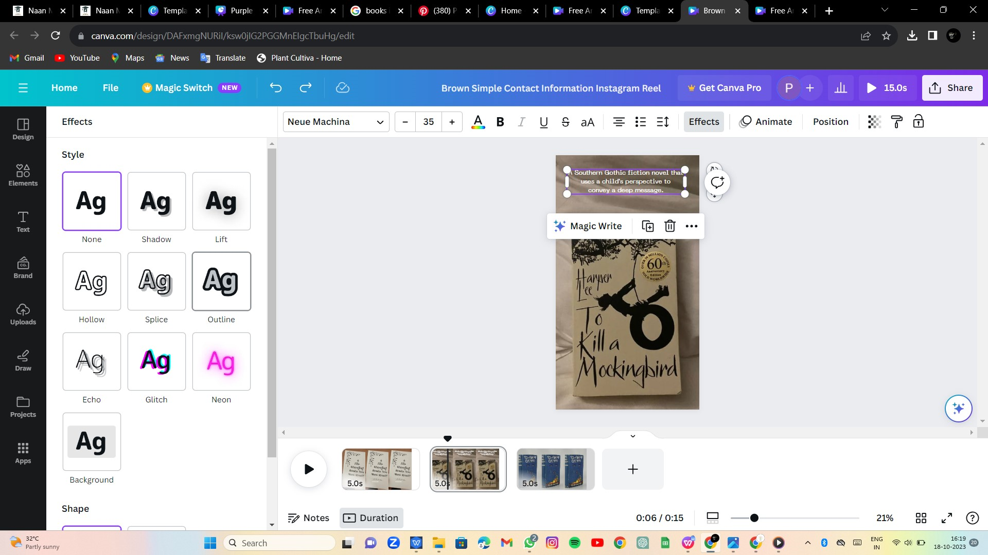

**15.SHARE AND DOWNLOAD**

Click “Share”

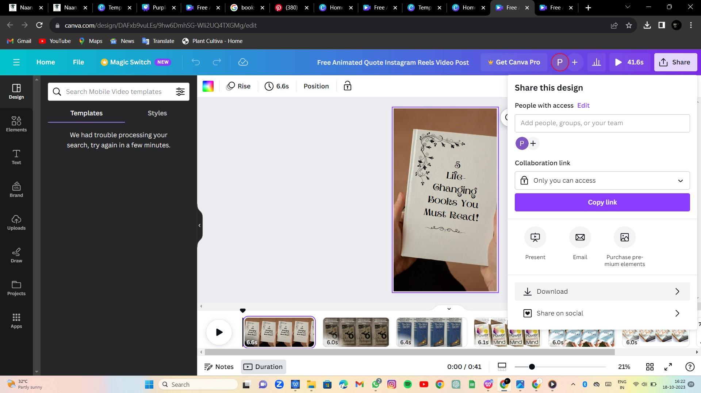

**16.RESULT**

We Created a Reel Design successfully using the Canva.

**16.1 BUSINESS E-MAIL**

<saaruinc08@gmail.com>

**16.2 REEL URL**

[https://www.instagram.com/reel/CykduV1L7dn/?igshid=MzRlODBiNWFlZA==](INSTA)